**Market Analysis Report for National Clothing Chain**

**Summary Report**

* The correlation value (R^2) between X_Income and Y_Sales is **0.78**, indicating a strong positive correlation between the two variables where as income increases the sales also increase.

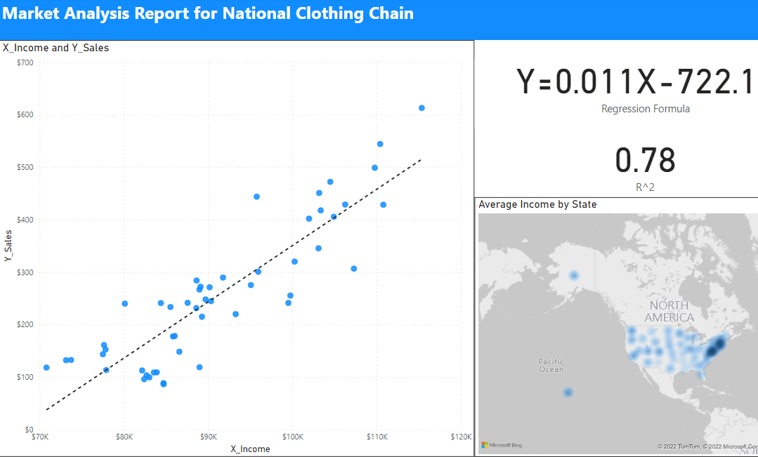

* The correlation value (R^2) between customer ratings and product return rate is **0.69**, indicating a strong negative correlation between the two variables where products having high customer ratings have low product return rates depicting the inverse relationship.

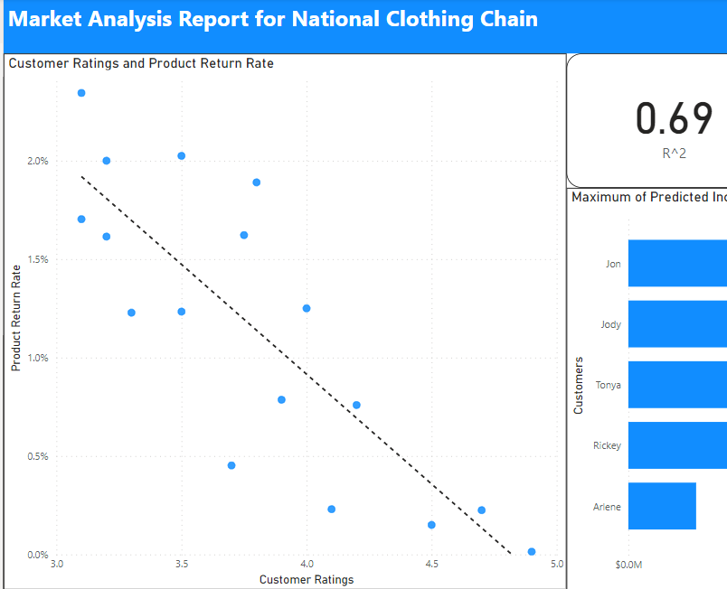

* The linear regression formula to predict income from customer sales is **Y = 0.011X - 722.14.**

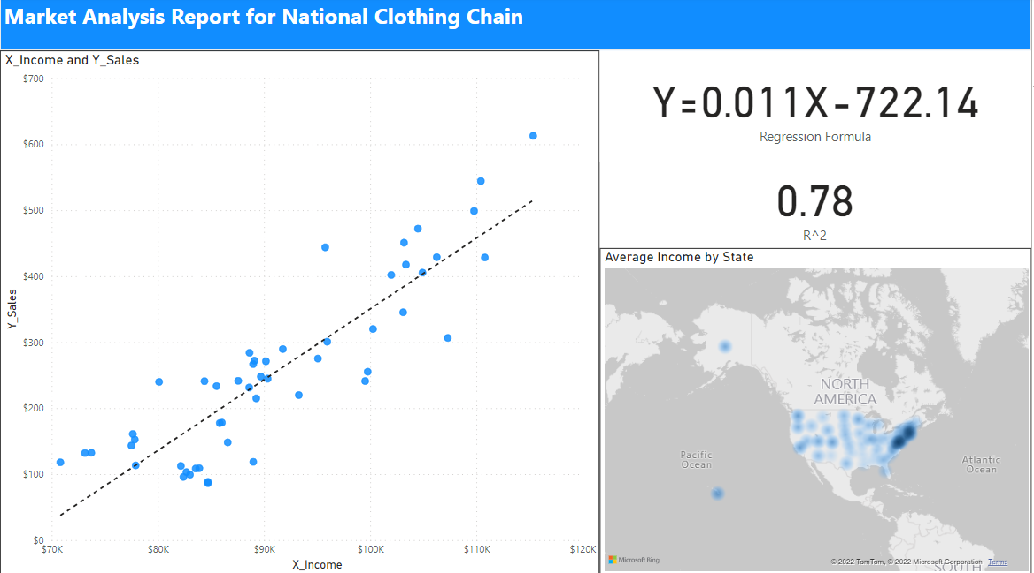

* According to the predicted income, **Jon** has the highest predicted income of **$4,76,550.5873.**

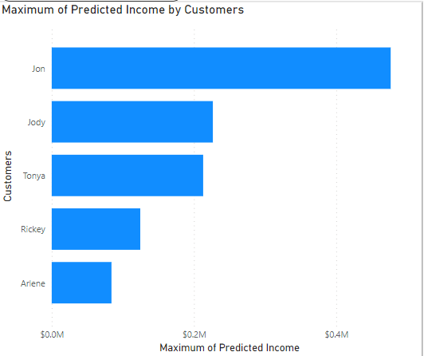

* Out of the 3 products that the national clothing chain wants to target, specifically the **Shirt($25)** should be advertised the most.

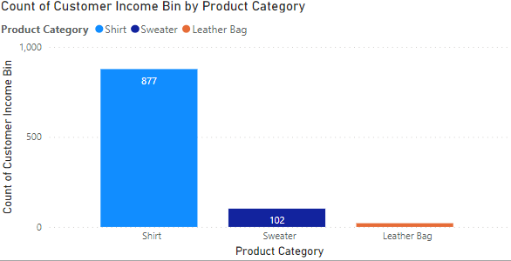

**Marketing Strategy**

* Since there are a significant number of customers below the predicted income bracket of $50,000, a product that is low in price specifically the shirt($25) should be advertised the most as it covers a major share of the customer base. This is also indicated by the income distribution histogram being right-skewed with a peak in incomes less than $20K.

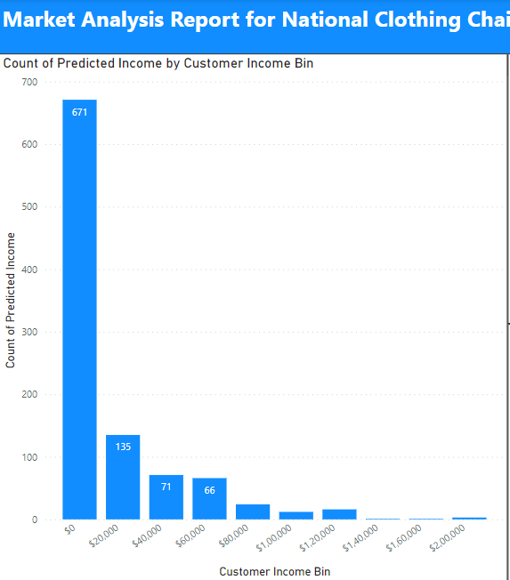



* Using a decomposition tree to analyze population by states, industries, and predicted incomes enables targeting of the segmented population involved in industries with higher incomes so as to market products that are on the pricier end. Industries have also been included so that corporate merchandise can be undertaken to boost the visibility of the brand.

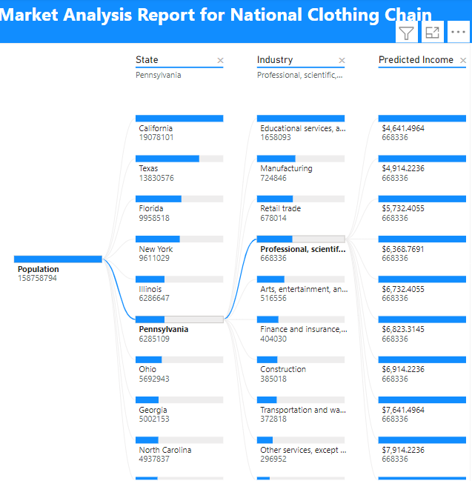

* Since there is a strong negative correlation between customer ratings and product return rate, online ad campaigns can also be run for products with high customer ratings.



Power Query

* Product Inventory

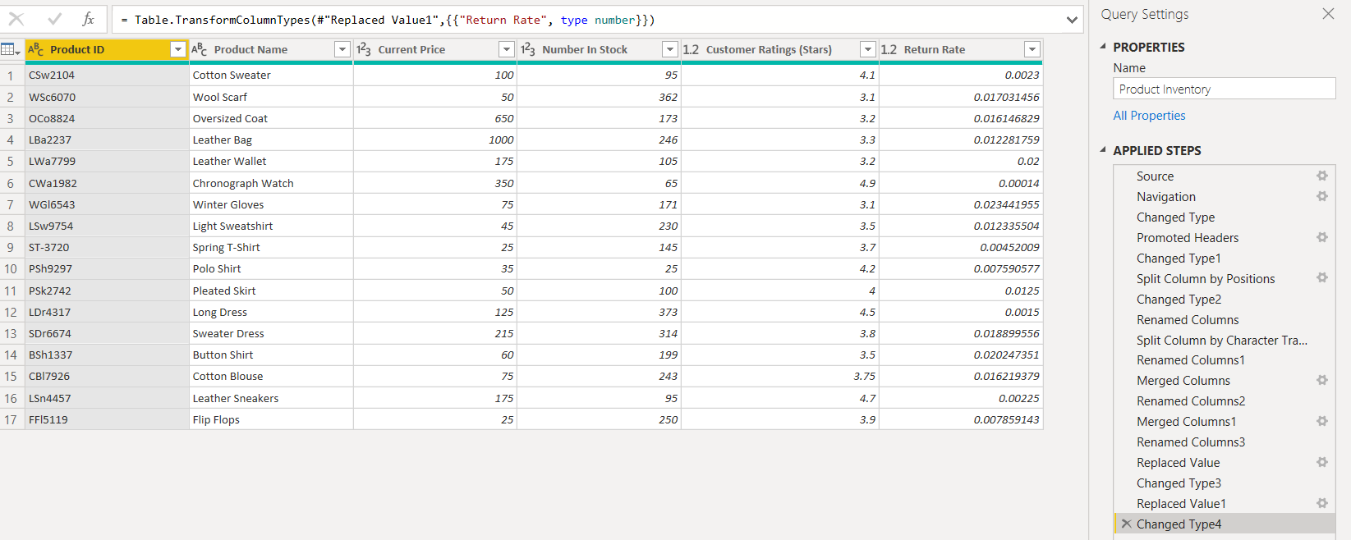

* Purchase List

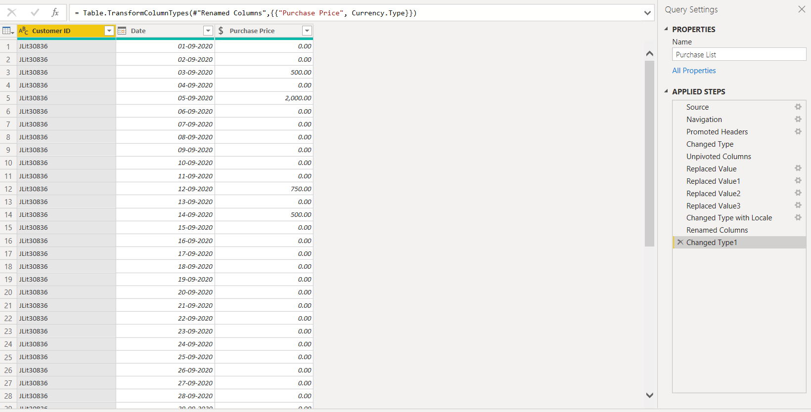

DAX

* Customer Income Bin (Income Categories)

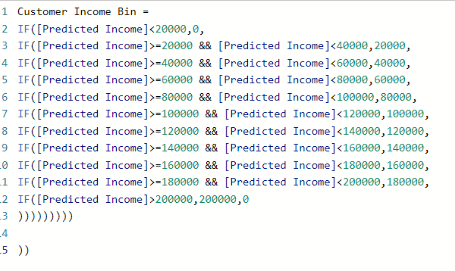

* Product Recommendations

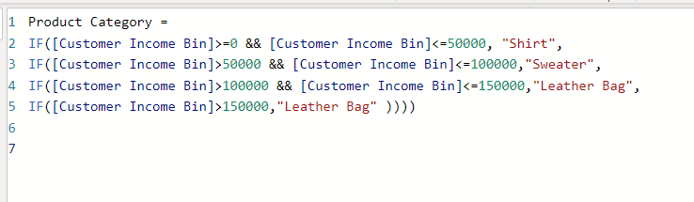

* Linear Regression to predict future outcomes



* Histogram Visualization



* Scatter Plot and Card Visualization for the relationship between average household income by state and average 6 months sales by state.
* 
* Heatmap for income household income distribution across the US.

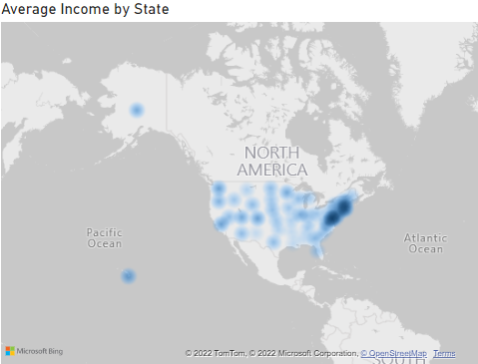

**Cross Filters**

* The histogram columns can be used to update the heatmap

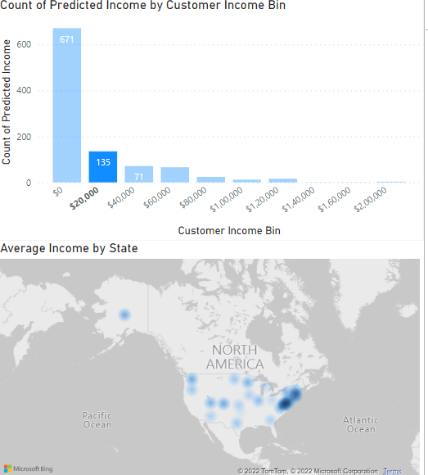

* The scatterplot can be used to update the histogram.

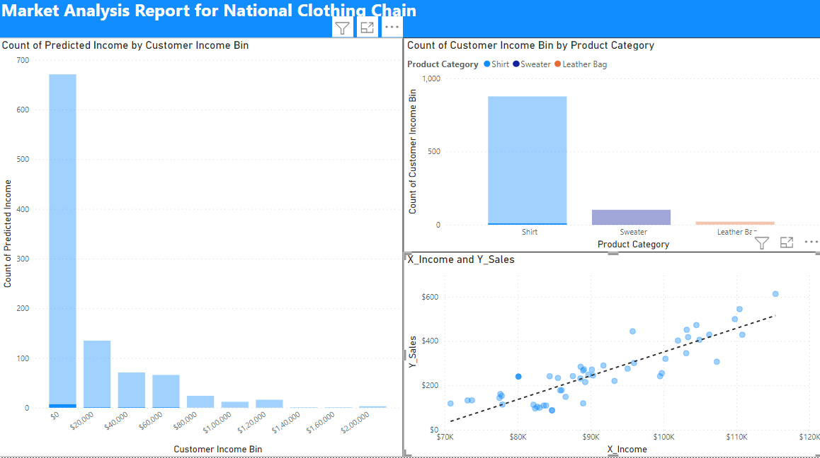

* The scatterplot can be used to update the map.

